PROJECT-42
AI Expense Categorizer
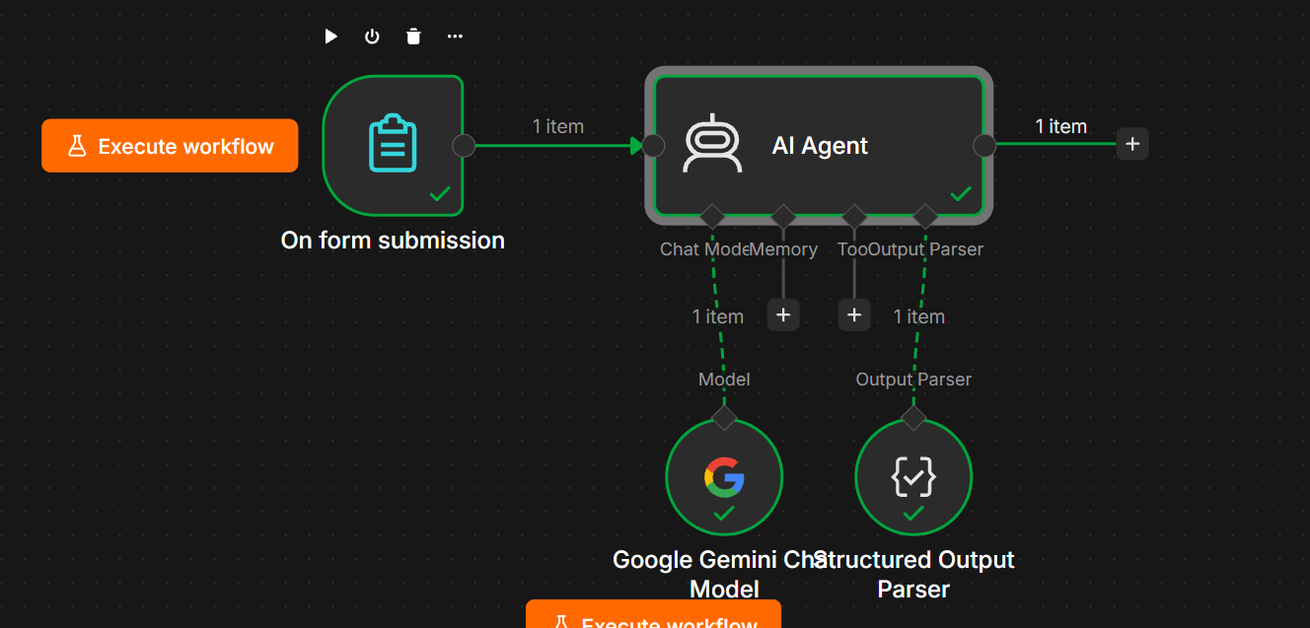

1. Project Overview
The AI Expense Categorizer is an AI-powered workflow built using n8n and Google Gemini.
The workflow accepts an employee's expense information through an n8n Form, sends the information to an AI Agent, and automatically determines the appropriate expense category and expense type.
Example
Input:
Employee Name: jon
Expense Amount: 256
Merchant: amazon
Expense Description: Taxi ride to client meeting
AI Output:
{
"employee_name": "jon",
"amount": 256,
"merchant": "amazon",
"category": "Transportation",
"expense_type": "Taxi",
"reason": "The expense description specifies a taxi ride to a client meeting, which falls under transportation."
}

2. Objective
The objective of this project is to automate expense classification using AI.
The system can:
- Collect employee expense details.
- Analyze the expense description.
- Identify the appropriate expense category.
- Identify the specific expense type.
- Preserve the submitted amount.
- Preserve the merchant name.
- Provide a reason for the classification.
- Return structured JSON output.

3. Technologies Used
Technology | Purpose
n8n | Workflow automation
n8n Form | Collect expense information
AI Agent | Analyze the expense
Google Gemini Chat Model | AI language model
Structured Output Parser | Generate consistent JSON output

4. Workflow Architecture
The workflow is:
On Form Submission
↓
AI Agent
↓
Structured Output
Parser
The AI Agent uses:
Google Gemini Chat Model
↓
AI Agent
So the complete workflow is:
┌───────────────────────┐
│ On Form Submission │
│ │
│ Employee Name │
│ Expense Amount │
│ Merchant │
│ Expense Description │
└───────────┬───────────┘
│
▼
┌───────────────────────┐
│ AI Agent │
│ │
│ Analyze Expense │
│ Categorize Expense │
└───────────┬───────────┘
│
▼
┌───────────────────────┐
│ Structured Output │
│ Parser │
└───────────────────────┘

AI Agent
│
└── Chat Model
↓
Google Gemini

5. Node 1 — On Form Submission
Node Name
On Form Submission
Purpose
This node collects the employee's expense information.
Form Fields
The workflow uses four main fields.
Field | Type | Example
Employee Name | Text | jon
Expense Amount | Number | 256
Merchant | Text | amazon
Expense Description | Text Area | Taxi ride to client meeting

5.1 Employee Name
Field
Employee Name
Type
Text
Example
jon

5.2 Expense Amount
Field
Expense Amount
Type
Number
Example
256

5.3 Merchant
Field
Merchant
Type
Text
Example
amazon

5.4 Expense Description
Field
Expense Description
Type
Text Area
Example
Taxi ride to client meeting
Why Text Area?
The expense description may contain multiple words or a longer explanation, so Text Area is more suitable than a single-line text field.

6. Node 2 — AI Agent
Node
AI Agent
Purpose
The AI Agent analyzes the submitted expense and determines:
- Expense category
- Expense type
- Reason for classification
It also carries the original:
- Employee name
- Amount
- Merchant
into the final response.

7. AI Agent Prompt
The user prompt used in the AI Agent is:
Employee Name:
{{ $json['Employee Name'] }}

Expense Amount:
{{ $json['Expense Amount'] }}

Merchant:
{{ $json['Merchant'] }}

Expense Description:
{{ $json['Expense Description'] }}

Categorize this expense.

Allowed categories:
Travel
Transportation
Food & Dining
Accommodation
Office Supplies
Software & Subscriptions
Marketing
Utilities
Healthcare
Entertainment
Education
Professional Services
Equipment
Other

Return the category, expense type, and a short reason.

8. Dynamic Expressions
The workflow uses n8n expressions to retrieve values from the form.
Employee Name
{{ $json['Employee Name'] }}
Expense Amount
{{ $json['Expense Amount'] }}
Merchant
{{ $json['Merchant'] }}
Expense Description
{{ $json['Expense Description'] }}
These expressions allow the AI Agent to receive the actual information submitted by the employee.

9. AI Agent System Message
The AI Agent is configured as an AI Expense Categorizer.
The system message defines the AI's responsibilities and the allowed categories.
Example:
You are an AI Expense Categorizer.

Your job is to analyze employee expense submissions and categorize them accurately.

Allowed categories are:

Travel
Transportation
Food & Dining
Accommodation
Office Supplies
Software & Subscriptions
Marketing
Utilities
Healthcare
Entertainment
Education
Professional Services
Equipment
Other

IMPORTANT RULES:

1. Categorize the expense based on the description and merchant.
2. Only use categories from the allowed category list.
3. Do not invent missing information.
4. Preserve the submitted expense amount.
5. Preserve the merchant name.
6. Identify a specific expense type such as Taxi, Meal, Hotel, Flight, Subscription, Laptop, etc.
7. Provide a short reason for the selected category.
8. If the expense cannot be confidently categorized, use "Other".
9. Return the result using the required structured output format.

10. Expense Categories
The AI is instructed to use these categories:
Category | Example
Travel | Flights, travel tickets
Transportation | Taxi, Uber, fuel
Food & Dining | Meals, restaurant
Accommodation | Hotels
Office Supplies | Pens, notebooks
Software & Subscriptions | Canva, Microsoft 365
Marketing | Advertising
Utilities | Electricity, internet
Healthcare | Medical expenses
Entertainment | Events, entertainment
Education | Courses, training
Professional Services | Consulting
Equipment | Laptop, monitor
Other | Unclear expenses

11. Expense Type
The expense type represents the specific nature of the expense.
For example:
Expense Description | Category | Expense Type
Taxi to client meeting | Transportation | Taxi
Lunch with client | Food & Dining | Meal
Hotel during business trip | Accommodation | Hotel
Flight to Mumbai | Travel | Flight
Canva monthly plan | Software & Subscriptions | Subscription
Laptop for work | Equipment | Laptop
Pens for office | Office Supplies | Stationery
Google Ads campaign | Marketing | Advertising
This is different from the category.
Category
Broad classification.
Transportation
Expense Type
Specific expense.
Taxi

12. Node 3 — Google Gemini Chat Model
Node
Google Gemini Chat Model
Purpose
Google Gemini provides the AI model that understands the expense description and generates the classification.
Connection
Connect the Gemini node to the AI Agent's:
Chat Model
It should not be connected as the normal workflow path.
Correct:
AI Agent
│
└── Chat Model
↓
Google Gemini Chat Model

13. Node 4 — Structured Output Parser
Node
Structured Output Parser
Purpose
The Structured Output Parser ensures that the AI returns information in a predictable structure instead of random text.
It is connected to the AI Agent's:
Output Parser

14. Structured Output Format
The parser uses the following structure:
{
"employee_name": "jon",
"amount": 256,
"merchant": "amazon",
"category": "Transportation",
"expense_type": "Taxi",
"reason": "The expense description specifies a taxi ride to a client meeting, which falls under transportation."
}

15. Connection Structure
The final connections should be:
On Form Submission
│
▼
AI Agent
│
▼
Structured Output Parser
And:
Google Gemini Chat Model
│
▼
AI Agent
Chat Model
The parser is connected to the Output Parser port of the AI Agent.

16. Example Execution
Input
An employee submits:
Employee Name:
jon

Expense Amount:
256

Merchant:
amazon

Expense Description:
Taxi ride to client meeting

AI Analysis
The AI identifies:
Description → Taxi ride
Purpose → Client meeting
Therefore:
Category → Transportation
Expense Type → Taxi

Final Output
{
"employee_name": "jon",
"amount": 256,
"merchant": "amazon",
"category": "Transportation",
"expense_type": "Taxi",
"reason": "The expense description specifies a taxi ride to a client meeting, which falls under transportation."
}

17. Additional Test Cases
Test Case 1 — Meal
Input
Employee Name:
John

Expense Amount:
850

Merchant:
Restaurant

Expense Description:
Dinner with a client
Expected
{
"category": "Food & Dining",
"expense_type": "Meal"
}

Test Case 2 — Hotel
Input
Employee Name:
John

Expense Amount:
5000

Merchant:
Marriott

Expense Description:
Hotel stay during business trip
Expected
{
"category": "Accommodation",
"expense_type": "Hotel"
}

Test Case 3 — Software
Input
Employee Name:
John

Expense Amount:
2000

Merchant:
Canva

Expense Description:
Monthly Canva subscription for marketing team
Expected
{
"category": "Software & Subscriptions",
"expense_type": "Subscription"
}

Test Case 4 — Equipment
Input
Employee Name:
John

Expense Amount:
65000

Merchant:
Dell

Expense Description:
Laptop purchased for office work
Expected
{
"category": "Equipment",
"expense_type": "Laptop"
}

18. Unknown Expense Handling
If the AI cannot determine the category confidently, it should use:
Other
Example:
Expense Description:
Miscellaneous purchase
Expected:
{
"category": "Other"
}
The AI should not create a new category that is not in the allowed list.

19. Error Prevention
The workflow has several rules to improve reliability.
Do not invent information
If the description does not provide enough information, the AI should not make up details.
Preserve amount
If the form contains:
256
the AI should return:
256
Preserve merchant
If the form contains:
amazon
the AI should return:
amazon
Use allowed categories only
The AI should not return:
Taxi Expenses
as a new category.
Instead:
Transportation

20. Advantages
Automation
Employees don't need to manually categorize every expense.
Consistency
The same category rules can be applied to every submission.
Structured Data
The output can easily be sent to:
- Google Sheets
- Excel
- Database
- Accounting system
Easy Integration
The workflow can later be extended with approval and reporting systems.

21. Future Enhancements
Once the current workflow is working, additional nodes can be added.
Google Sheets
Form
↓
AI Agent
↓
Google Sheets
This can create an automated expense database.

Expense Approval
Form
↓
AI Agent
↓
IF
├── Normal Expense → Auto Process
│
└── High Expense → Manager Approval

Email Notification
AI Agent
↓
Gmail
↓
Finance / Manager

Expense Dashboard
The categorized expenses can be stored in Google Sheets or a database and connected to Power BI for reporting.
Possible dashboard metrics:
- Total Expenses
- Expenses by Category
- Expenses by Employee
- Monthly Expenses
- Transportation Expenses
- Food Expenses
- Highest Expense
- Average Expense

22. Final Workflow
Your current working project can be summarized as:
AI EXPENSE CATEGORIZER

┌─────────────────────────────┐
│ ON FORM SUBMISSION │
│ │
│ Employee Name │
│ Expense Amount │
│ Merchant │
│ Expense Description │
└──────────────┬──────────────┘
│
▼
┌─────────────────────────────┐
│ AI AGENT │
│ │
│ Analyze Expense │
│ Select Category │
│ Identify Expense Type │
│ Generate Reason │
└──────────┬─────────┬────────┘
│ │
│ └──── Chat Model
│ │
│ Google Gemini
│
└──── Output Parser
│
▼
Structured JSON
Final Output Structure
{
"employee_name": "...",
"amount": 0,
"merchant": "...",
"category": "...",
"expense_type": "...",
"reason": "..."
}
Project Status
Based on the workflow you showed, your AI Expense Categorizer is successfully working. The form submission, Gemini AI classification, category selection, expense type detection, reason generation, and structured output are all functioning correctly.

